Work Outline:

part1 - clean data:

1.clean FEC data:

***->step1:preprocess the data***

0)remove the lines where last name == “” or first name == “” or state abbrev == “”

e.g.,

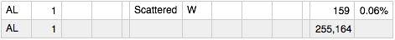

1)add year attribute

2)delete all dirty data and reformat numeric data which was written in string format

clean the data:

***->step2:merge the data***

e.g.,

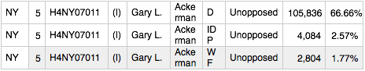

one candidate was named by three parties

part2: hypothesis analysis Preprocess:

1.reformat the data:

original data format:



new data format:

the attributes contain:

KEY, YEAR, STATE, FIRST, LAST, DISTRICT, CANDIDATE, PARTY, INDUSTRYPERCENT, CANDTOTAL, INCUMBENT, VOTES PERCENT, WINNER,

rank 1, rank 2, rank 3, rank 4, rank 5, rank 6, rank 7, rank 8, rank 9, rank 10, rank 11, rank 12

AMOUNT of 1, AMOUNT of 2, AMOUNT of 3, AMOUNT of 4, AMOUNT of 5, AMOUNT of 6, AMOUNT of 7, AMOUNT of 8, AMOUNT of 9, AMOUNT of 10, AMOUNT of 11, AMOUNT of 12

attribute 1~19 in the table 

attribute 20~44 in the table 

in this format, it is easy to do decision tree, kNN and Naive Bayes

2.give missing data a default value:

give all categorical attribute missing data a default value NULL, and all numeric attribute missing data a default value as 0.





3.filter some too sparse attribute or unnecessary attributes in hypothesis analysis



e.g., last name, first name, etc. are not important in the model to predict whether the man will win the campaign.

4.bin the data(amount of no.1 donation industry to amount of no.12 donation of data and candTotal) This is for NaiveBayes analysis, which only accepts categorical attributes.



Part3: Hypothesis Analysis

Decision Tree Model:

Summary:

I want to show you the result first and then describe the details. So let’s take a look at the result first:

Compare the three models

|  |  |  |  |
| --- | --- | --- | --- |
|  | DT | kNN | Naïve Bayes |
| Prediction accuracy | 0.881 | 0.839 | 0.879 |
| Prediction variance | 0.105 | 0.135 | 0.106 |
| Area under the ROC curve | 0.842 | 0.893 | 0.871 |
| 95% CI | 0.812-0.872(DeLong) | 0.867-0.919(DeLong) | 0.842-0.899(DeLong) |
| hypothesis 1 | Wrong. Feature “rank1 amount” and feature “rank5 amount” are more important than others | Wrong. These features are the same important. | Wrong. These features are the same important. |
| hypothesis 2 | Right. | Wrong. | Right. |
| hypothesis 3 | Feature Candtotal is important, but YrPercentChange is not. | Both of them are not important. | Feature Candtotal is important, but YrPercentChange is not. |

[note]

[hypothesis 1]: in prediction, the feature of rank1 amount of money is more important than rank2 amount of money, and rank2 amount of money is more important than rank3 amount of money, ...

[hypothesis 2]:is incumbent feature important?

[hypothesis 3]: Candtotal and YrPercentChange important?

[Prediction] In this experiment, I am trying to predict whether the candidate can win the campaign.

[Conclusion]

Compare these three models, all of them work pretty well, which really surprises me. I never thought the model can predict the winner of campaign with accuracy above 0.8.

And in these three models, decision tree seems work best.

Here are the details of the three models’ results:

1.Tree structure after pruning:

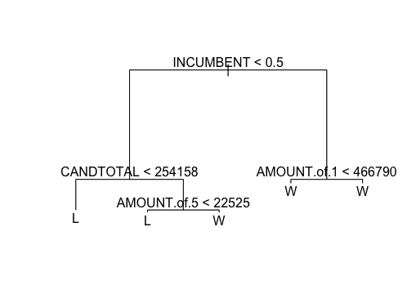

I use cv_tree$dev~cv_tree$size to decide the tree’s size and do pruning: in this case, I choose size=3 according to the following graph:

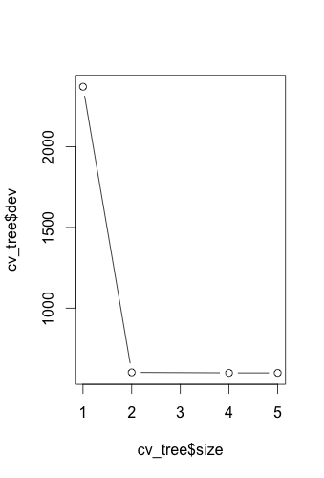

2.tree hypothesis results:

[hypothesis 1]: in prediction, the feature of rank1 amount of money is more important than rank2 amount of money, and rank2 amount of money is more important than rank3 amount of money, ...

[result]Wrong.

rank1 amount of money and rank5 amount of money is really important in tree model. rank2 amount of money~rank4 amount of money are not important.

[hypothesis 2]:is incumbent feature important?

[result]It is the most important feature. It is the root of the tree, which means its information gain is the biggest in all attributes.

[hypothesis 3]: Candtotal and YrPercentChange important?

[result]Candtotal is important.

But YrPercentChange is not important. It is not a node in the decision tree.

3.[prediction analysis]

What am I doing here:

I try to use the data we collect to predict whether the politician will win the campaign or not. Here is the result:

|  |  |  |  |  |  |  |
| --- | --- | --- | --- | --- | --- | --- |
| tree model | confusion matrix | accuracy | variance | TRUE | false positive | true positive |
| run1 | tree_predict_after_prune  L W  L 222 15 W 45 258 | 0.889 | 0.099 | 300 | 0.150 | 0.850 |
| run2 | tree_predict_after_prune  L W L 204 14 W 44 278 | 0.893 | 0.096 | 322 | 0.137 | 0.863 |

[Note] L represents Loser and W represents Winner

Similarly, I run it 10 times, the mean(accuracy) is 0.881 and variance is 0.105, which is amazing for me.

4.[ROC analysis]:

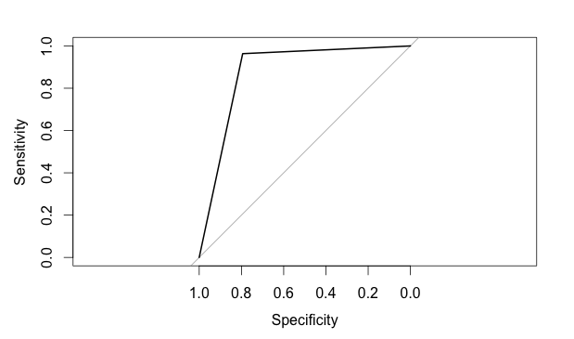

(Note: I cannot set smooth=TRUE because there is not enough nodes. I try “trainset:testset = 1:1, but it is still not enough”)

result:

Area under the curve: 0.8929

95% CI: 0.8672-0.9187 (DeLong)

the area under the curve is pretty high, which means the model works pretty well.

kNN analysis(Lazy Model)

[hypothesis 1]: in prediction, the feature of rank1 amount of money is more important than rank2 amount of money, and rank2 amount of money is more important than rank3 amount of money, ...

[Answer] Wrong. seems that they are the same important.

the below is the result if we discard the feature rank1 amount/rank2 amount/...

***[situation 1]without attribute: rank1 amount of money***

result

testTarget L W

L 176 85

W 6 273

Accuracy: 0.8314815

Variance: 0.14038

***[situation 2]without attribute: rank2 amount of money***

result

testTarget L W

L 194 70

W 14 262

Accuracy: 0.8444444

Variance: 0.1316017

***[situation 3]without attribute: rank3 amount of money***

result

testTarget L W

L 179 72

W 18 271

Accuracy: 0.8333333

Variance: 0.1391466

***[situation 4]without attribute: rank4 amount of money***

result

testTarget L W

L 193 63

W 16 268

Accuracy: 0.8537037

Variance: 0.1251254

***[situation 5]without attribute: rank5 amount of money***

result

testTarget L W

L 200 57

W 17 266

Accuracy: 0.862963

Variance: 0.1184773

[hypothesis 2]: is incumbent feature important?

[Answer]: No it is not very important. It is different from DT and Naive Bayes.

result

testTarget L W

L 211 64

W 8 257

Accuracy: 0.8666667

Variance: 0.1157699

[hypothesis 3]: Candtotal and YrPercentChange important?

[Answer]: No. Candtotal is not important.

result

testTarget L W

L 184 75

W 12 269

Accuracy: 0.8388889

Variance: 0.1354051

without attribute: percentage

result

testTarget L W

L 195 70

W 9 266

Accuracy: 0.8537037

Variance: 0.1251254

There are not big change of accuracy after I discard the attribute Candtotal or YrPercentChange

Result Analysis

I try to use the data to predict whether the guy can win the campaign or not. Here is the result:

Mean Accuracy = 0.83925926

Variance = 0.13503195

The result is amazing. We can predict the result with accuracy of 0.84.

ROC analysis

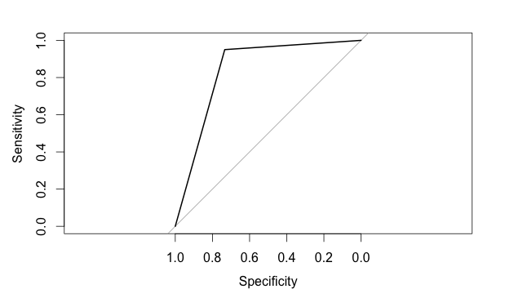

Area under the curve: 0.8419

95% CI: 0.8121-0.8717 (DeLong)

the area under the curve is pretty high, which means the model works pretty well.

Naïve Bayes Model

1.hypothesis analysis

[hypothesis 1]: in prediction, the feature of rank1 amount of money is more important than rank2 amount of money, and rank2 amount of money is more important than rank3 amount of money, ...

Wrong. seems that they are the same imporant.

the below is the result if we discard the feature rank1 amount or rank2 amount/...

from which, we can see that the accuracy, variance and confusion matrix don’t change a lot.

***[situation 1]without attribute: rank1 amount of money***

Confusion Matrix:

pred L W

L 252 38

W 27 223

Accuracy: 0.8796296

Variance: 0.1060778

***[situation 2]without attribute: rank2 amount of money***

Confusion Matrix:

pred L W

L 228 32

W 36 244

Accuracy: 0.8740741

Variance: 0.1102728

***[situation 3]without attribute: rank3 amount of money***

Confusion Matrix:

pred L W

L 249 37

W 20 234

Accuracy: 0.8944444

Variance: 0.09458874

***[situation 4]without attribute: rank4 amount of money***

Confusion Matrix:

pred L W

L 247 36

W 27 230

Accuracy: 0.8833333

Variance: 0.1032468

***[situation 5]without attribute: rank5 amount of money***

Confusion Matrix:

pred L W

L 235 40

W 31 234

Accuracy: 0.8685185

Variance: 0.114406

[hypothesis 2]:is incumbent feature important?

Yes. whether the man/woman is the incumbent is the most important feature. If we discard this feature, the model's performance is as following:

pred L W

L 134 17

W 135 254

Accuracy: 0.7185185

Variance: 0.2026249

The accuracy drops a lot.

[hypothesis 3] Candtotal and YrPercentChange important?

No. Candtotal and YrPercentChange are not important. The top 5 money donation attributes work well.

The accuracy doesn’t change much after I delete the attribute YrPercentChange or CandTotal.

without attribute: YrPercentChange

pred L W

L 242 34

W 25 239

Accuracy: 0.8907407

Variance: 0.09750223

without attribute: total amount of money(Candtotal)

pred L W

L 240 36

W 37 227

Accuracy: 0.8648148

Variance: 0.1171271

[Prediction Result Analysis]

Mean Accuracy = 0.8788889

Variance = 0.10642135

The result is amazing. We can predict the result with accuracy of 0.84.

[ROC analysis]

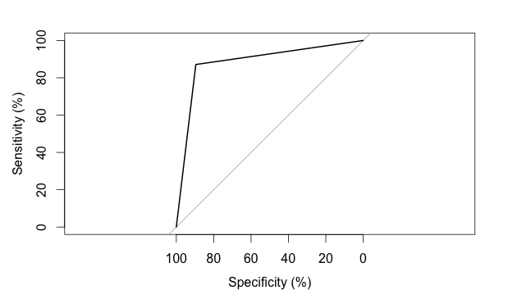

Area under the curve: 87.05%

95% CI: 84.22%-89.87% (DeLong)

the area under the curve is pretty high, which means the model works pretty well.

Code citation:

Naïve bayes:

#code citation: https://cran.r-project.org/web/packages/e1071/e1071.pdf

#code citation: https://cran.r-project.org/web/packages/pROC/pROC.pdf

kNN:

#code citation: https://cran.r-project.org/web/packages/pROC/pROC.pdf

#code citation: https://www.youtube.com/watch?v=GtgJEVxl7DY

#code citation: https://www.youtube.com/watch?v=DkLNb0CXw84

#code citation: https://cran.r-project.org/web/packages/class/class.pdf

Decision Tree:

#code citation: https://www.youtube.com/watch?v=GOJN9SKl_OE

#code citation: https://cran.r-project.org/web/packages/ISLR/ISLR.pdf

#code citation: https://cran.r-project.org/web/packages/pROC/pROC.pdf